COM535 Cyber Security Lab

Instructions

- Visit https://www.hacksplaining.com/lessons

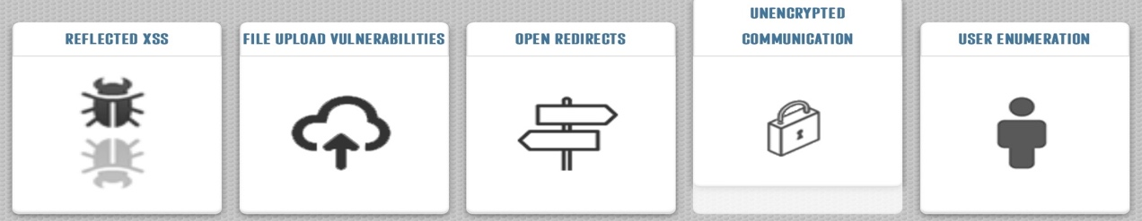

- Complete the five vulnerability lessons which are Reflected XSS, File upload vulnerabilities, Open redirects, Unencrypted communication and User enumeration.

Tryhackme

- We are going to look at fundamentals of How the Web Works.

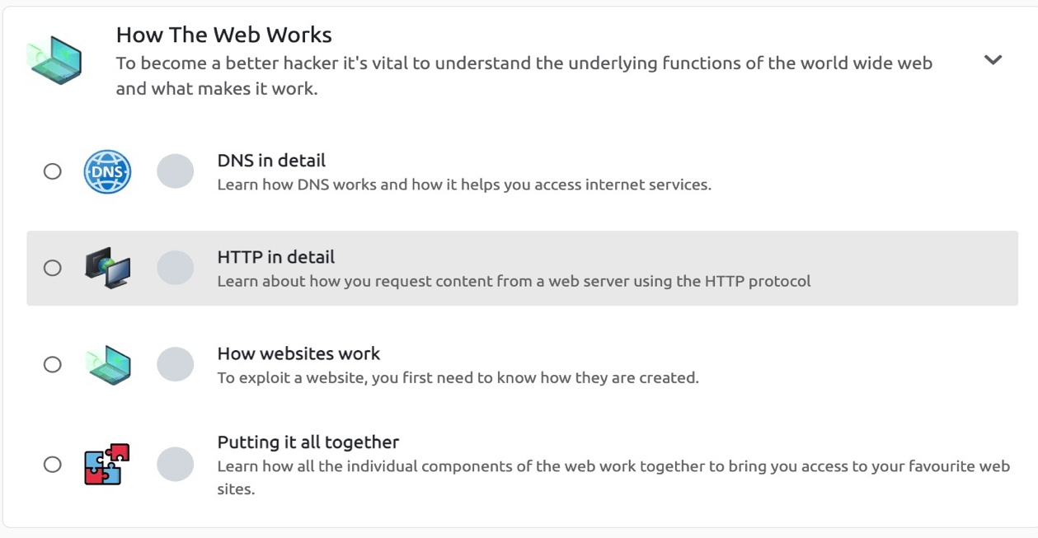

- Complete DNS in detail https://tryhackme.com/jr/dnsindetail

Video Walkthrough help: https://youtu.be/_FpMPxnHDps

- Complete HTTP in detail https://tryhackme.com/jr/httpindetail

Video Walkthrough help: https://youtu.be/rNuZ6f1i2Fw

- Learn the basics of web applications: HTTP, URLs, request methods, response codes, and headers in the Web Application Basics module.

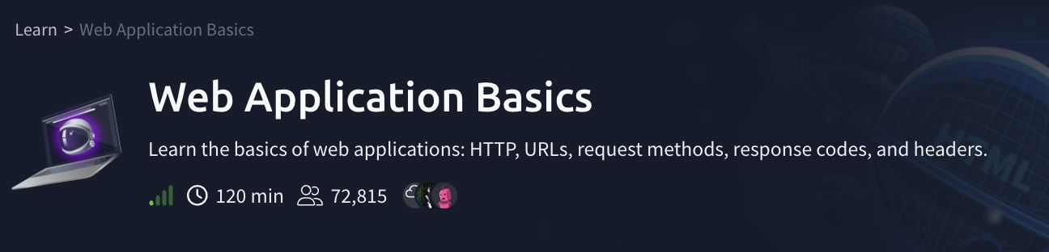

- Complete Web Application Basics at: https://tryhackme.com/room/webapplicationbasics

Video Walkthrough help: https://www.youtube.com/watch?v=VOHVj5it90c

- Finally, continue to Blue where you deploy & hack into a Windows machine, leveraging common misconfigurations issues.

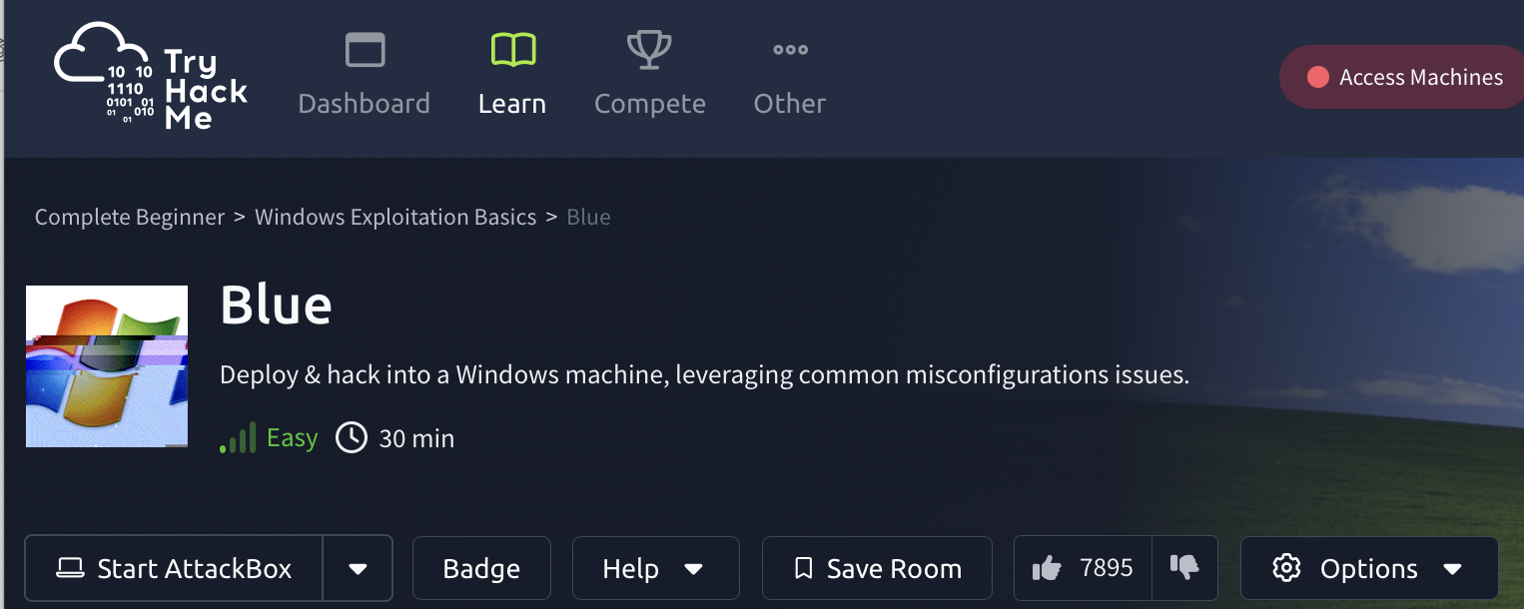

- Complete Blue at: https://tryhackme.com/r/room/blue

Video Walkthrough help: https://www.youtube.com/watch?v=32W6Y8fVFzg

